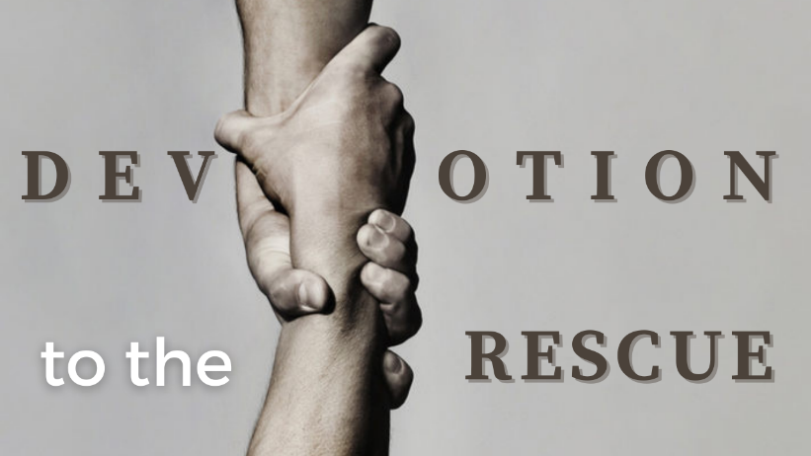
The Good Narrative
Study Guide

- Read Matthew 5:21-24. In this passage, what specific ways does Jesus deepen the understanding of the law against murder? How does this deeper understanding relate to the dignity and worth of individuals?

- Read John 14:23. What does this passage tell us about the way we are to abide by God’s laws?

- Read Matthew 5:20. What do you think Jesus means by surpassing the “righteousness of the Pharisees”? How can we do this?

