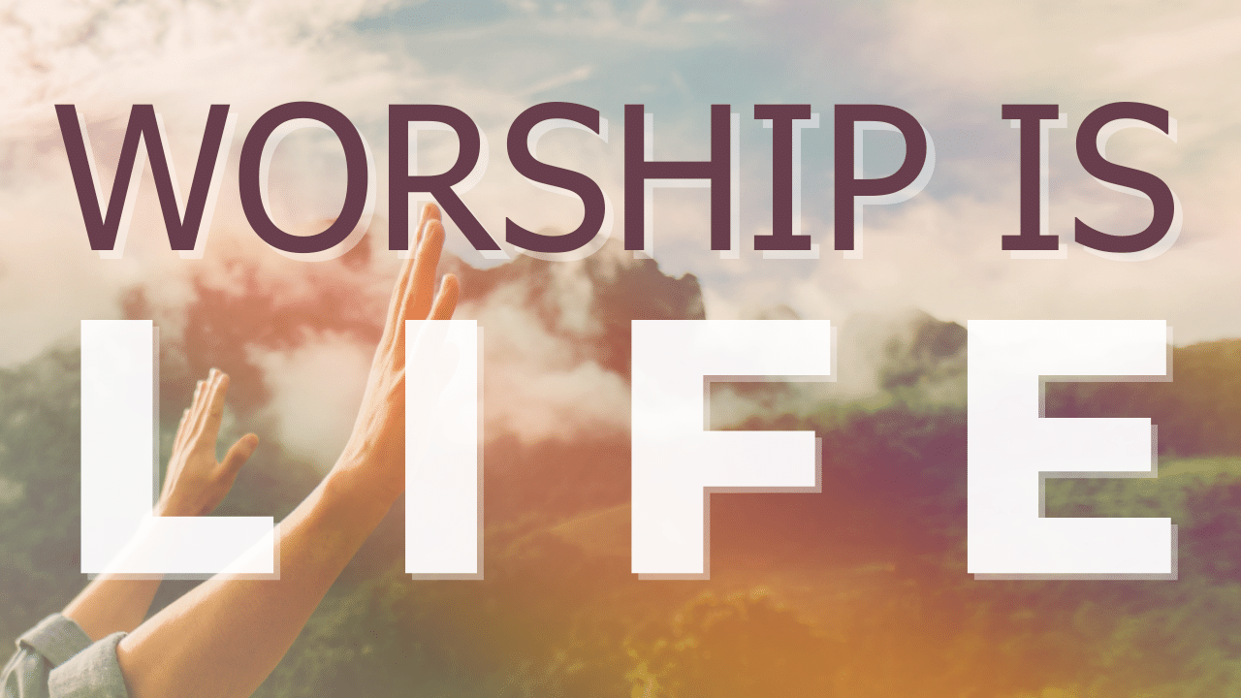
Worthy
Study Guide

- Read Revelation 4:2-8, Exodus 19:16-19 and Psalm 18:12-15. What are your impressions of God as depicted in these passages? How do they compare with your mental image of God?

- Read Revelation 5:6-10, Isaiah 53:6-7, and Luke 2:6-14. How do these three descriptions of the Christ fit together? Do they clarify or confuse your understanding of God?

- Read Revelation 5:9-10 and 2 Corinthians 5:20. How do these passages speak to our mission as people who believe in Jesus?

