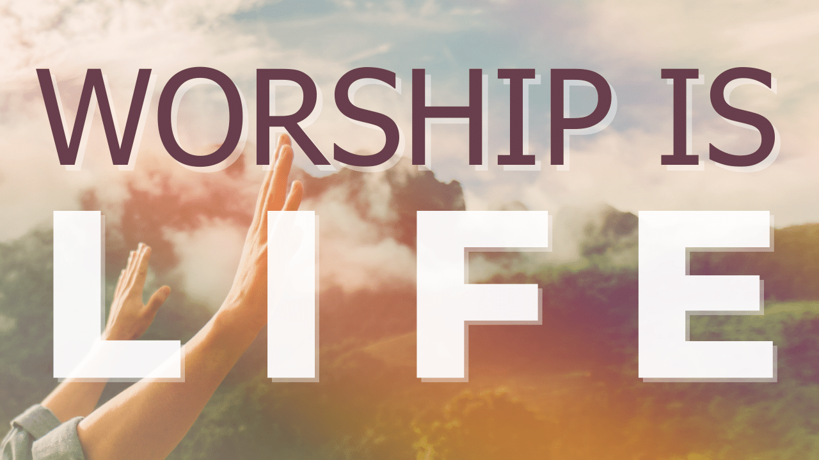
Stop, Listen and Look
Study Guide

- Read Ecclesiastes 3:1-8. Think of one word that describes your feelings when you hear these verses. What do they tell you about God? What do they tell us about ourselves?

- Read Ecclesiastes 5:1-2. What is the hardest thing about prayer? Why do you think it might be harder to listen than to talk when in prayer? Why does the Teacher call many words in prayer the “sacrifice of fools”?

- Read Ecclesiastes 5:5 and Judges 11:30-40. Why does the Teacher recommend against making “vows” to God? Are vows and promises to God ever appropriate? Have you ever made a vow or promise to God?

