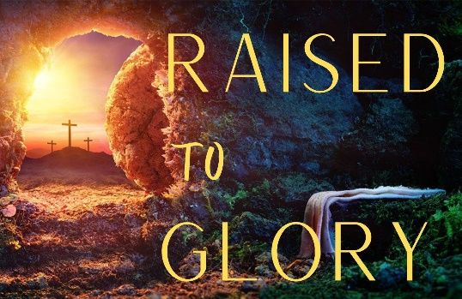
Next New Thing
Study Guide

- Read Genesis 12:1-3, Genesis 15:1-6 and Genesis 18:1-2; 9-15. What is asked of Abraham in this passage? What promises are made to him?

- Read Romans 4:18-22. What was ‘credited as righteousness’ to Abraham? What does this passage tell us about the kind of faith Christians should have?

- Read Romans 4:23-25. In this passage, what is the key to having ‘faith that is credited as righteousness’?

