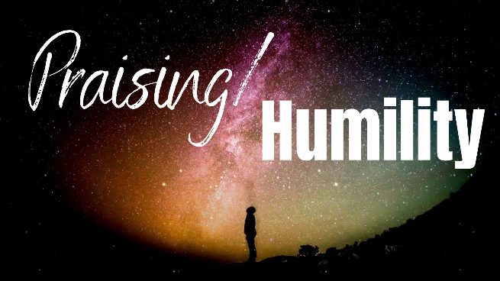
“God’s Vineyard”
Study Guide

- Read Isaiah 5:20-21. In your opinion, what are the most disturbing social or moral trends you’ve witnessed in your lifetime?

- What Biblical teachings to these trends oppose or contradict? If left unchecked, what do you suppose our culture will look like in thirty years?

- What role do you think the church can play in reversing these trends and healing these ills? What current successes give you hope for the future?

