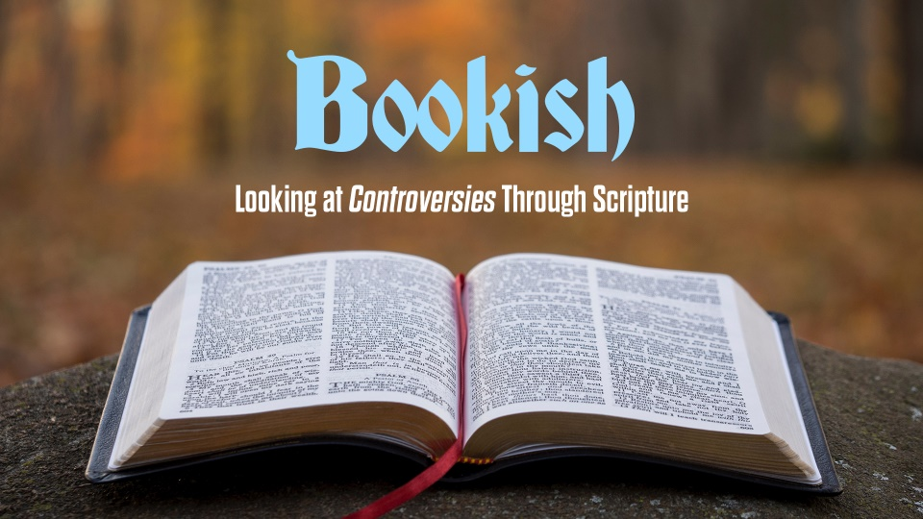
Purify Our Hearts
Study Guide

- Read Genesis 4:7-12. How does Cain’s punishment fit his crime? Now read Genesis 4:13-16. Why do you think God protects Cain?

- Read Romans 5:6-8. Paul tells us that “…while we were still sinners, Christ died for us”. Why do you think God did this for us? If we believe this is true, what do you think should die in us in return?

- Read Luke 9:23. What does this verse mean to you? Has there been a “cross” you’ve needed to bear or sacrifice you’ve had to make to follow Jesus?

