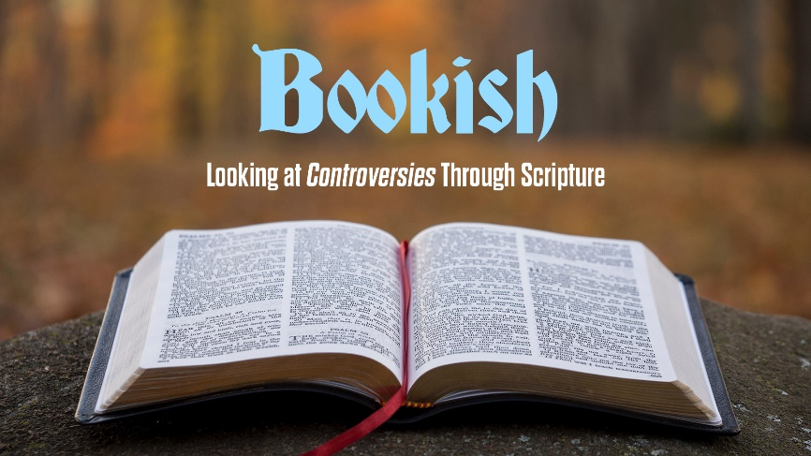
A New Revelation
Study Guide

- Referring to his Methodists, John Wesley said: “…We believe, indeed, that “all Scripture is given by the inspiration of God…We believe the written word of God to be the only and sufficient rule both of Christian faith and practice…We believe Christ to be the eternal, supreme God…But as to all opinions which do not strike at the root of Christianity, we think and let think.” Other than those Wesley mentions, are there any other essential pillars of the Christian faith? What are some “non- essentials” of the faith about which Christians should agree to “think and let think”?

- Read Acts 10:14. What do you think Peter has in mind when he says that God accepts everyone who “fears him and does what is right”?

- Read Acts 10:44. Why di you think Peter and the others were “astonished” at the outpouring of the Holy Spirit on the Gentiles? Have you ever been astonished by the goodness of people you considered to be sinners? Can the Holy Spirit inspire bad people to do good things?

