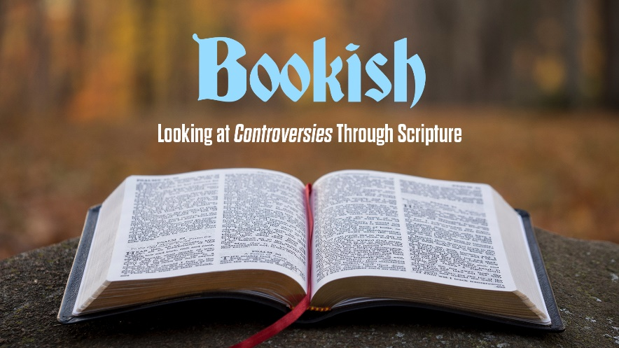
“Bookish”
Study Guide

- John Wesley said” “I want to know one thing, the way to heaven—how to land safe on that happy shore. God himself has condescended to teach the way, for this very end he came from heaven. He has written it down in a book.” Do you agree? If so, can you name three ways the Bible tells us how to get to heaven?

- Read John 4:1-3. What are some ideas about Jesus, God, or attitudes of modern life that Christians need to “test” against the Scriptures?

- John Wesley said: “In all cases, the Church is to be judged by the Scripture, not the Scripture by the Church.” What does this mean to you? If you were to substitute your name for the word “Church” in this statement, what might you have to change in yourself?

