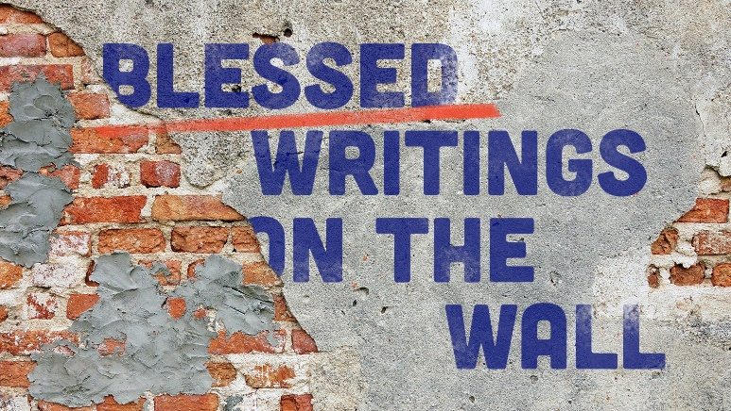
“Wartime”
STUDY GUIDE

- Do you find it hard, or easy to believe that evil is destined to be defeated?

- Read Genesis 3:15. What does this verse tell us about who is expected to fight evil? How does this verse point to Jesus?

- What good things can we do daily to fight the war against evil?

