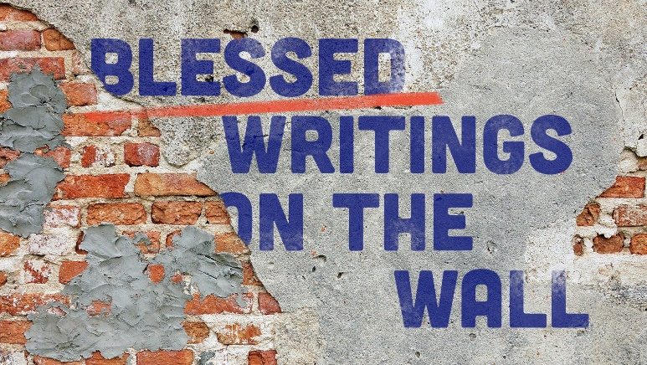
“He Purchased Our Peace”
Study Guide
- It is said that war has a way of clarifying what’s important in life and what’s not. Have these last few weeks changed your perspective in this way?

- In your view, is war ever justified? How should Christians think about war?

- Read Isaiah 52:13-53:12. What is the role of this “suffering servant? In your opinion, which passages point most directly to Jesus?

