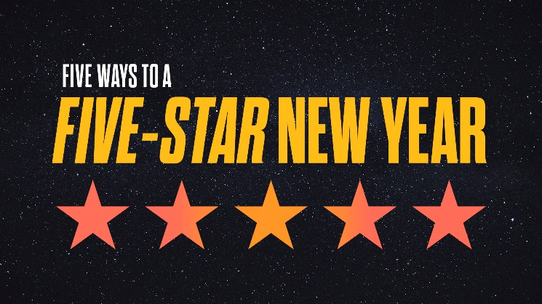
Start the New Year Righteous
- What words come into your mind when you think of someone being “righteous”?

- Read Psalm 1:1-2 (NIV). How does the way of the “blessed” differ from the way of the “wicked” the “sinner” and the “mockers”? What does it mean to be a “mocker?”

- Compare Psalm 1:3 with Psalm 37:3. How are they similar in their description of being in right relationship with God?

