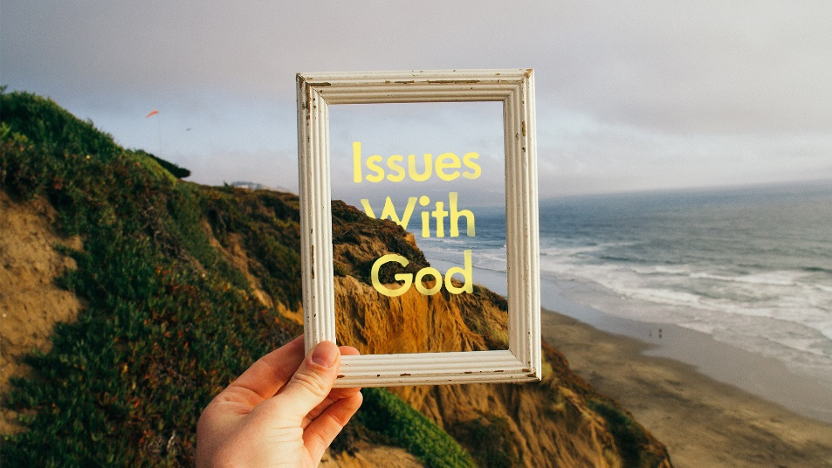
What’s Up with Heaven Part 2

- In the New Earth we will know ourselves the way God knows us and fully be who he has made us to be. Imagine at least one answer to the following questions about the New Earth:
  - What things do you love to do now that you hope to do there? What will it be like to do them?
  - What things that you’ve not been able to do in this life do you hope to do there?
  - Besides Jesus, who are the people you would like to talk to? What will you ask them?
  - What are the things you long to learn now that you hope to learn there?

- Read John 14:1-4. What do you think Jesus means by “many rooms”?

