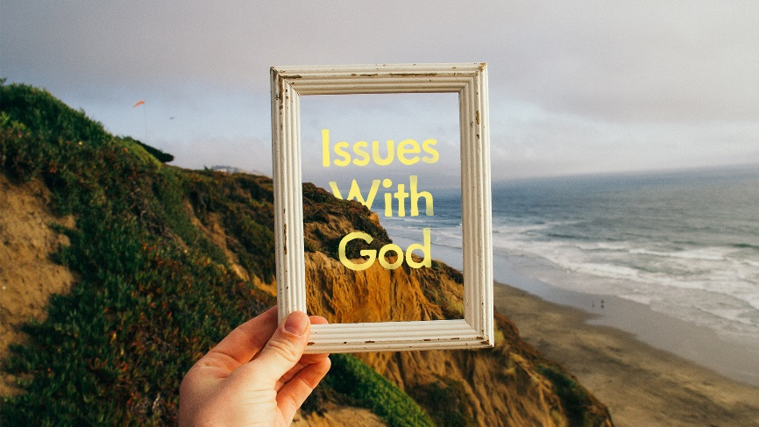
Having Issues with God
- Do you agree that suffering can bring us closer to God? What are some reasons why that might be true?

- How do you view the balance between God’s sovereignty and our free will? Does God set limits on our free will?

- Read Psalm 23. What verse or verses speak most powerfully to you about God’s presence in your life?

