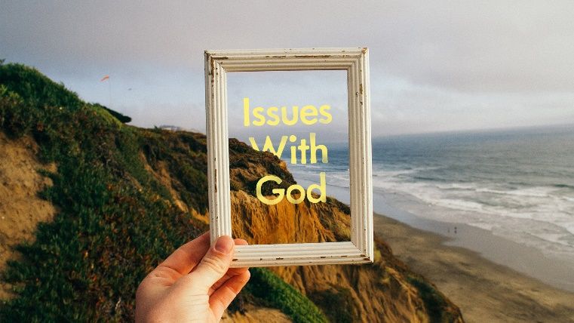
“Sex and Separation”
- Read Genesis 2:7 and 1 Corinthians 6:19-20. What do these passages tell us about the union of our bodies and the spirit of God?

- Read the following quote from CS Lewis’ “Mere Christianity”. What does it say about the acts of the body and the condition of the spirit?
“Remember, we Christians think man lives forever. Therefore, what really matters is those little marks or twists on the central, inside part of the soul which are going to turn it, in the long run, into a heavenly or a hellish creature.”

- Read 2 Corinthians 5:17 and the following excerpt from the Methodist Articles of Religion:
“Sanctification is that renewal of our fallen nature by the Holy Ghost, received through faith in Jesus Christ, whose blood of atonement cleanseth from all sin; whereby we are not only delivered from the guilt of sin, but are washed from its pollution, saved from its power, and are enabled, through grace, to love God with all our hearts and to walk in his holy commandments blameless”
What do these passages say about our ability to live as “image bearers” of God?

