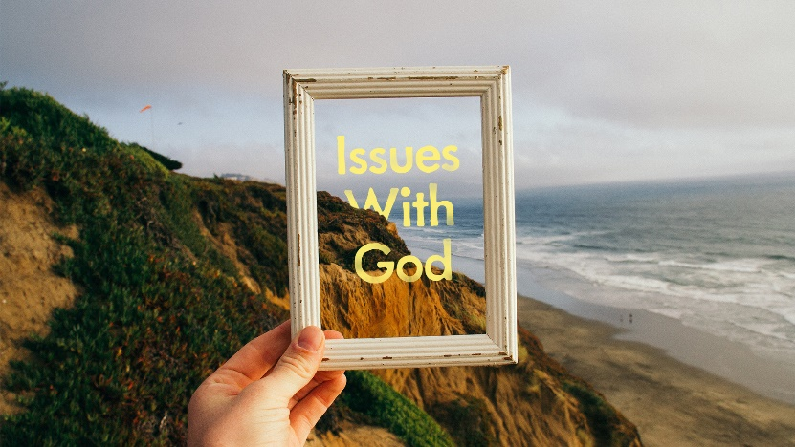
Navigating Social Media:
“Issues with Self-Esteem”

- In the world’s view, our Self-Esteem = Performance + Other’s Opinions. What are the pitfalls of measuring our self-worth this way?

- God tells us that our self-worth begins with his declarations about us. Read Psalm 139:1-18. Find at least three declarations about us that tell how special we are to God.

- Read Philippians 4:8. What does Paul’s admonition tell us about our role us as “image bearers” of God?

