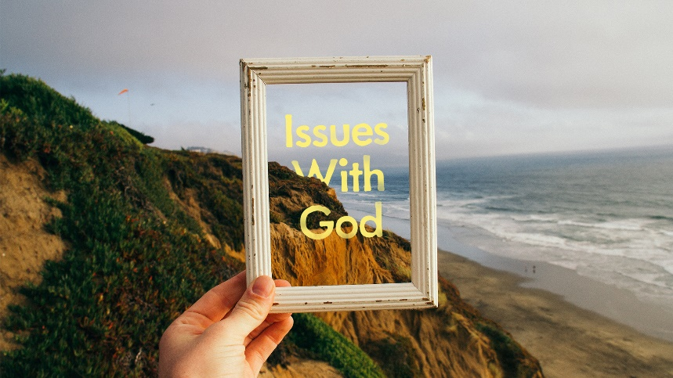
“Internet Alarms”
- Read Genesis 2:16-17 and Genesis 3:1-4. Contrast the clarity with which God speaks to Adam and the way the Serpent deceives Eve. How does the Serpent’s speech mirror the way stories are sometimes told in the media?

- Read Proverbs 12:22 and John 14:6. What kind of value does God place on the truth? Why do you think that is?

- Read Genesis 1: 1-3 and Matthew 24:14 How can God’s power in the ordering of creation and Jesus’ declaration about the end times give us hope during our worrisome times?

