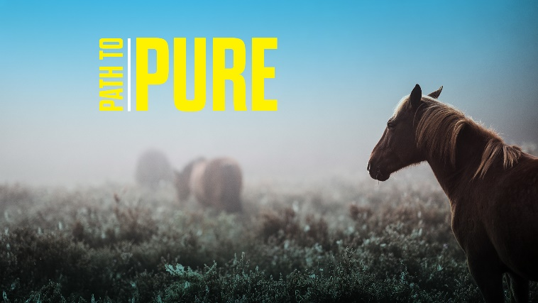
Path to Pure
“God’s Country”
Matthew 17:24-27

- Have you ever had to take a controversial stand because of your faith in a work, social or family setting? What was the outcome?

- Read Matthew 22:15-22. How does this passage clarify the boundaries between citizenship in our nation and in God’s Kingdom? How could it dissuade believers from bringing our faith in to the public square?

- Is there a public figure you admire whose work is informed by their faith? Who is it, and how are they inspirational to you?

