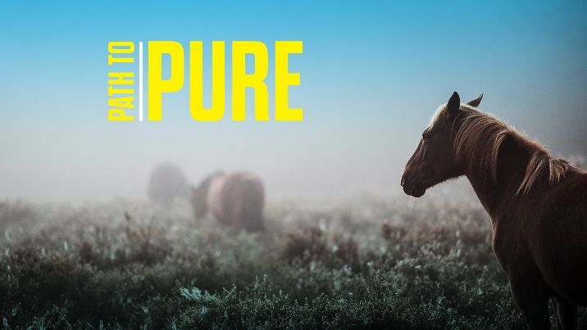
Path to Pure
“Impossibly Pure”
STUDY GUIDE

1. What signs of our current times unnerve you the most? Is there a sign of the present time that gives you hope for the future?

2. Read Matthew 6:16. What were some of the teachings and attitudes of the Pharisees and Sadducees that were contrary to Jesus’ Kingdom teachings? Do any of these teachings and attitudes still act to corrode our pure faith in Jesus?

3. Read Psalm 121. How many promises of God do you count in the Psalm? Choose the promise that resonates most with you. What does it mean to the living out of your daily life?

