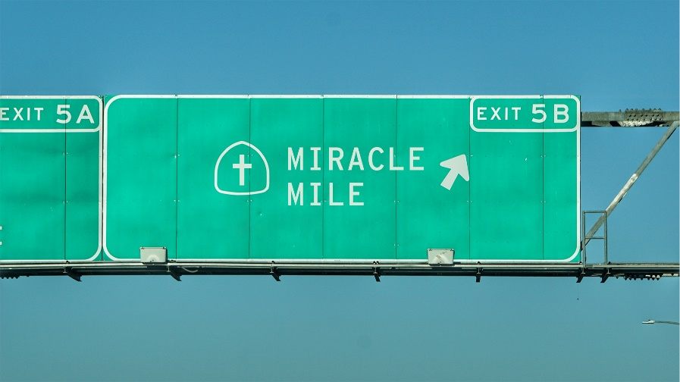
Miracle Mile:
“Speed of Life”
Study Guide

- Read Mathew 8:23-27, Luke 7:11-17, and John 6:16-21. Which of these miracles of Jesus do you like best? Why? In your view, what is the message behind your favorite miracle?

- Continue to think about the message of your favorite miracle. Has this message ever been proved true in your life?

- Anne Lamont once told this story: “Once I asked a priest friend, Boll Rankin, if he really believed in miracles, and he said that all I needed to do was to remember what my life used to be like and what it’s like now. He said he thought he ought to change my name to Exhibit A.” Is there an “Exhibit A” miracle that God has performed in your life? Is the miracle immediate, incremental, or both?

