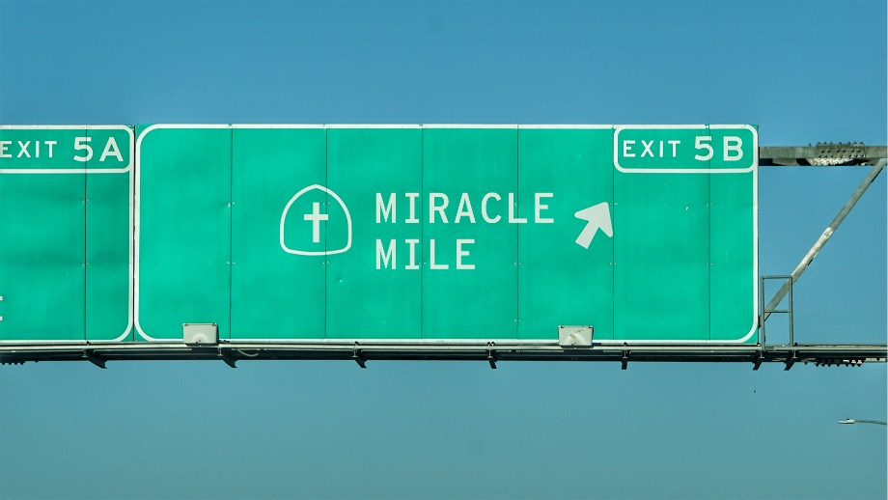
Miracle Mile:
“The Need that Binds”
Study Guide

- Have you ever suffered discrimination because of your race, class, culture or beliefs?

- Read Leviticus 10:10 and Exodus 34:11-16. What is the meaning of “unclean” here? How does it relate to differences among people?

- Read Acts 10:23-28 and Galatians 3:26-28. What do you notice about these passages?

- There is a lot of concern today about unconscious bias and racism. Do you agree or disagree that we can harbor racist feelings without knowing it? Read Luke 6:43-45. How does this help answer the question of conscious and unconscious racism?

