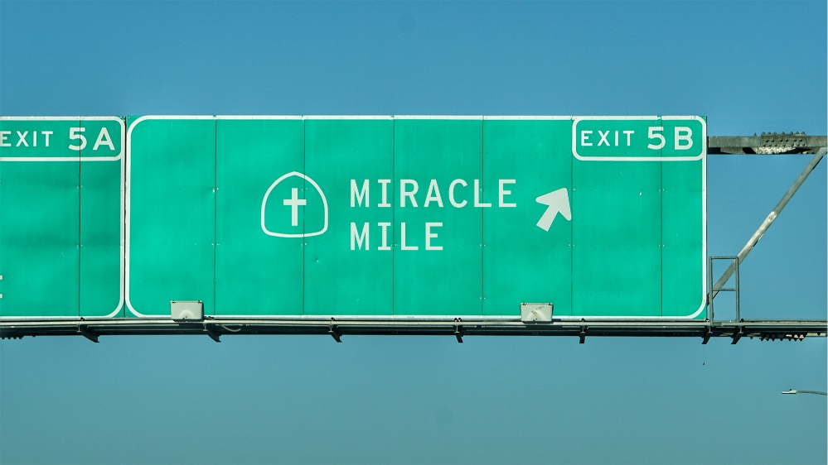

Miracle Mile
“Compatible”
STUDY GUIDE

- Has there ever been a habit or behavior from which you made a “clean break”? Why did you do it? How did you succeed?

- Read Galatians 5:16-25. Think about this list of behaviors that are incompatible and compatible with the Spirit. Which apply to you? Which to you wish applied to you on a more consistent basis?

- The New Wine of Jesus’ Spirit cannot be contained in a heart that is brittle and cracked like an old wineskin. What are some practices and habits you can cultivate this week that will make your heart more welcoming to Christ?

