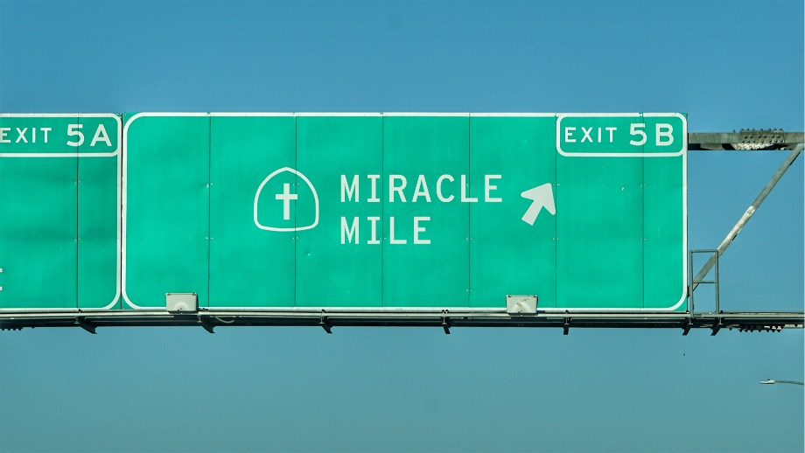

Miracle Mile:
“Paralyzing Past”
STUDY GUIDE

- Read John 9:1-5. What do these verses suggest about the connection between sin and physical problems? Is there ever a connection between sin and misfortune?

- Are there things you have done in the past for which you continue to feel guilty to this day? Does God’s offer of forgiveness in Christ help lighten that load? If so, how?

- Some people believe that God ordains everything that happens in a person’s life, while others believe that human free will plays a big role, but that God is present in all of our circumstances. What are some of the problems with each view? Which view is more in line with your experience? In your opinion, is either view more or less supported by scripture?

