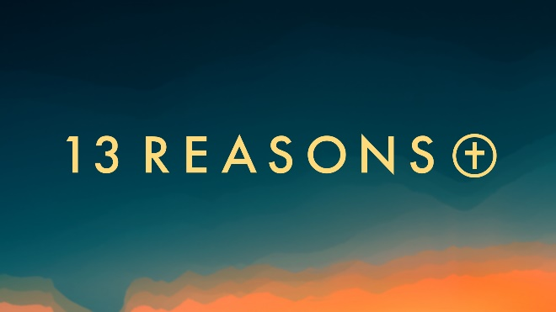
“It’s a-Life!”
Psalm 139:13-16
“For you created my inmost being..” Ps. 139:13
It’s good when the Author of life has authority over life.

It is said we can only make decisions by the “lights”, or the understanding we possess at any given time in our lives. What beliefs or values have influenced you most at different times in your life? ______________________________________________________________________________
______________________________________________________________________________
______________________________________________________________________________

“O Lord, you have searched me and you know me. You know when I sit down and when I rise, you perceive my thoughts from afar.”
Ps. 139:1
At first glance does this verse give you comfort, or make you feel uneasy? Why? _____________
______________________________________________________________________________
______________________________________________________________________________

Do you regularly include a time of confession in your prayer life? If so, describe the benefits of confession. ____________________________________________________________________
______________________________________________________________________________

“I praise you for I am fearfully and wonderfully made; your works are wonderful” Ps. 139:14
In your prayer time, are you more likely to dwell on your shortcomings or praise God for the “wonderful work” that is you? Why?_________________________________________________
______________________________________________________________________________
______________________________________________________________________________

In your opinion, is there a stage of development when pre-born or newborn life might have lesser or greater value, or its life have lesser or greater meaning? Why or why not?________________
____________________________________________________________________________________________________________________________________________________________

“You hem me in behind and before. You have laid your hand upon me.” Ps. 139:5
Is there a time in your life when you felt the presence of God with you in a particularly powerful way?__________________________________________________________________________
How did that experience shape you? ________________________________________________
______________________________________________________________________________

“God knows us, goes with us, and holds us from conception into eternity with Him.”
This week, what are three ways that this thought can help light the way forward for you and your family?________________________________________________________________________
______________________________________________________________________________
______________________________________________________________________________

Next week: “Truth’s Consequences”

“For since the creation of the world God’s invisible qualities—his eternal power and divine nature—have been clearly seen…so that men are without excuse.”

Relativism puts the preferences of individuals in the drivers seat, but the Church asserts that there is universal truth. Can you think of anything that was once considered a “universal truth” that is no longer thought to be so today? _____________________________________________
____________________________________________________________________________________________________________________________________________________________
What do you think is responsible for the change?______________________________________
______________________________________________________________________________
______________________________________________________________________________

