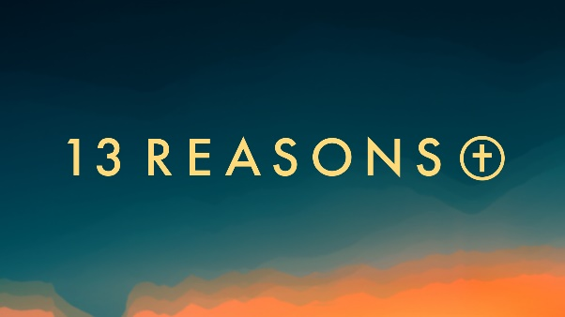
“Above the Law”
Romans 8:1-4
“Therefore, there is now no condemnation for those who are in Christ Jesus…” Romans 8:1

Sin is a spiritual condition brought on by the fall on mankind. What are the differences between “sin” as a spiritual condition and the “sins” we commit? What are some underlying conditions that lead to specific sins? _________________________________________________________
______________________________________________________________________________
______________________________________________________________________________
______________________________________________________________________________

A virus hijacks our cells’ DNA to replicate itself. How does sin hijack our spirit?______________ ______________________________________________________________________________
______________________________________________________________________________
______________________________________________________________________________
______________________________________________________________________________

God’s Law identified major symptoms of “sin-sickness” in the Ten Commandments. What are some other symptoms of “sin-sickness” that you have seen or experienced in your life? ______________________________________________________________________________
______________________________________________________________________________
______________________________________________________________________________
______________________________________________________________________________

“For what the law was powerless to do in that it was weakened by the sinful nature, God did by sending his own Son in the likeness of sinful man to be a sin offering.” – Romans 8:5
Have you ever felt powerless to prevent yourself from doing things you knew would be hurtful to yourself or others? To what do you attribute that weakness? A lack of desire? A lack of will power? Something else? _________________________________________________________
______________________________________________________________________________
______________________________________________________________________________
______________________________________________________________________________

Prior to his death on the cross, Jesus cried out: ““My God, my God, why have you forsaken me?” (Mark 15:34). Have you ever felt separated from God? When? What conditions precipitated the feeling? _____________________________________________________________________________________
______________________________________________________________________________
____________________________________________________________________________________________________________________________________________________________

“God made him who had no sin to be sin, for us…” - 2 Cor. 5:21

Jesus took on all the sin-sickness of the world and suffered sin’s death. What does Jesus’ resurrection say about sin? What does it mean for those who put their faith in Jesus?________________________________________________________________________
______________________________________________________________________________
______________________________________________________________________________
______________________________________________________________________________

Next Week: “Born Free” - John 3:5-9. Think of a time when you saw a new vista for the first time. Maybe it was from the summit of a mountain peak, or the first time you saw pictures of the Earth from space. How can seeing a new view change the way we see ourselves?

