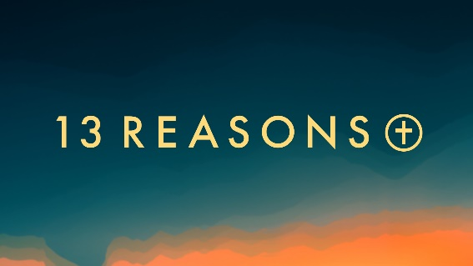
“A Long, Long Time”
Psalm 16:5-8
“Because he is at my right hand, I will not be shaken” – Psalm 16:5-8

Young people have a tendency to fixate on their immediate circumstances at the expense of a long-term view. What do you think contributes to short-sightedness in young and old alike?
______________________________________________________________________________
______________________________________________________________________________
______________________________________________________________________________

The way David sees God helps him define his perspective on himself. What are one or two aspects of who God is, that helps put who you are into perspective?______________________________
______________________________________________________________________________
______________________________________________________________________________
______________________________________________________________________________

Have you ever felt abandoned or utterly alone? When? To what or to whom did you turn in that time?_________________________________________________________________________
______________________________________________________________________________
______________________________________________________________________________
______________________________________________________________________________

What does the resurrection of Jesus say about God and his faithfulness? Does it say anything about you?_____________________________________________________________________
______________________________________________________________________________
______________________________________________________________________________

“the boundary lines have fallen for me in pleasant places; surely I have a delightful inheritance.” Psalm 16:6
What does this passage say to you about your relationship with God? ______________________________________________________________________________
______________________________________________________________________________
______________________________________________________________________________

“So do not worry, saying what shall we eat? or what shall we drink?, or what shall we wear?”…But seek first his kingdom and his righteousness and all these things will be given to you as well”
Matt. 6:31, 33
In what ways can God be seen as our ultimate source of security, care, counsel and confidence?____________________________________________________________________
______________________________________________________________________________
______________________________________________________________________________

Our faith is founded on an eternal God who raised Jesus from the dead. How does this fact put your hopes and concerns in perspective____________________________________________
______________________________________________________________________________
______________________________________________________________________________

Next Week: “Hear the Word”, 1 Samuel 24:1-4a. Is there a particular verse or story from Scripture that you can say “got under your skin” and changed you from within? What was it and how did it influence you?__________________________________________________________
____________________________________________________________________________________________________________________________________________________________

